C++ ASSIGNMENT 2

Q1.

Output is 0 as 6%6 is 0

Q2.

Output is 1 1 as both are true

Q3.

Output is 2

Q4.

#include<iostream>

using namespace std;

int main()

{

float radius,height;

cout<<"Enter radius and height of a cylinder: ";

cin>>radius>>height;

float volume= 3.14\*radius\*radius\*height;

cout<<"Volume of a cylinder is : "<<volume;

}

[\\ using](file:///\\using) programiz as vs code is not working properly

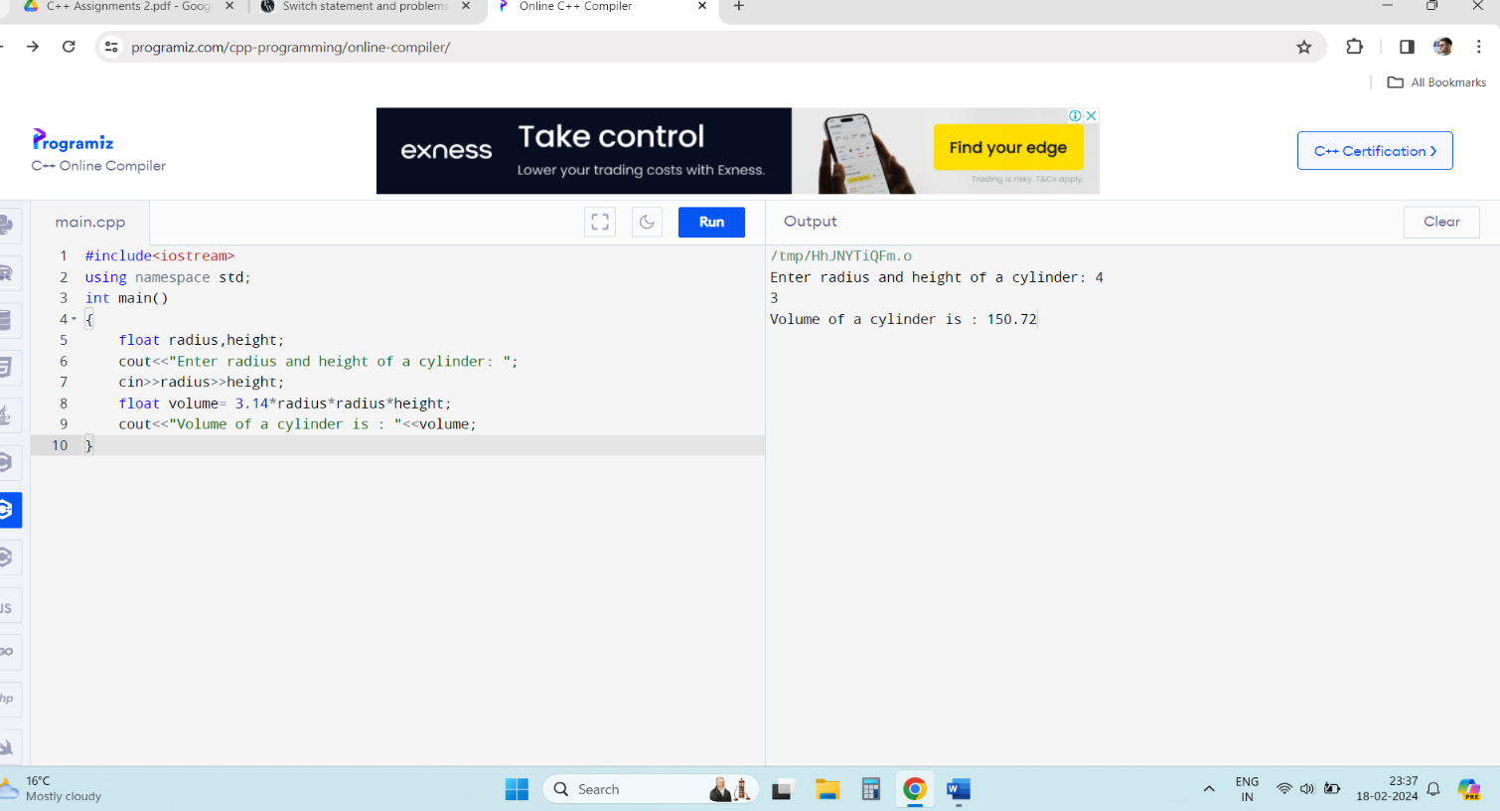

Q5.

#include<iostream>

using namespace std;

int main()

{

char ch1,ch2;

cout<<"Enter two character: ";

cin>>ch1>>ch2;

cout<<"Difference between ASCII characters is: "<<ch1-ch2;

}

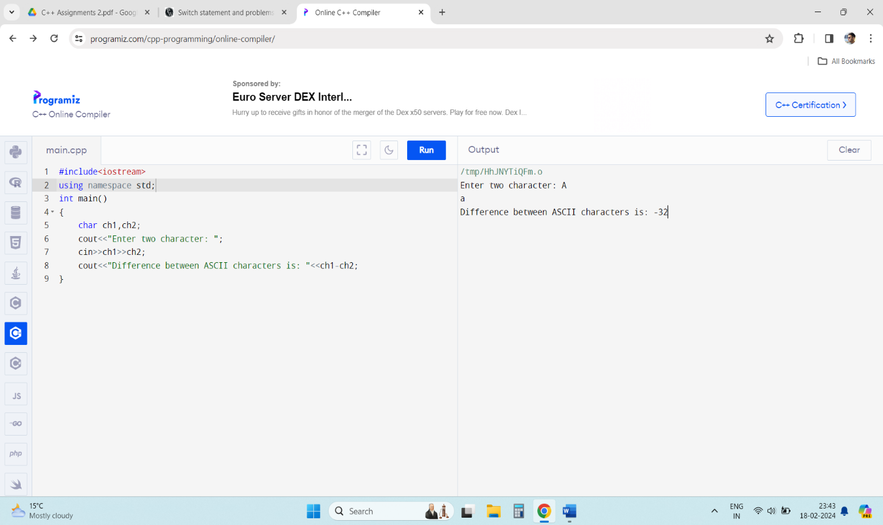

Q6.

Output is 49.